Draft Persona and Mood board – Team Azure
Professor Andy Cameron – CSC 3220
Yohanna, Damien, Sangam

Part 1 Persona
Demographics:
Name: David Henderson
Age: 34
Job title: Owner of a small pizzeria
Business type: Food (Restaurant)
Location: Leavenworth
Tech comfort level: Moderate
Pain & Frustrations:
- What stresses them out?
- runs out of stock unexpectedly
- overorders and stocks go to waste (waste money)
- tracks inventory manually but cannot keep track of the exact number (time-consuming)
- no low-stock alerts
- What problem does your app solve?
- real-time inventory tracking
- low-stock alert
- sales trend tracking
- smart reorder
- automated stock updates when sales occur
Needs & Goals:
What does the user want?
- An easier/simpler way to track their products (Low Stock, Overstock, Understocking, etc.)
- Centralized inventory management system.
- A system that tracks sales.
Part 2 Mood board

Typography:
Heading: StockPilot (Montserrat)
Body: Home (Open Sans)

Iconography (styles our app will use):
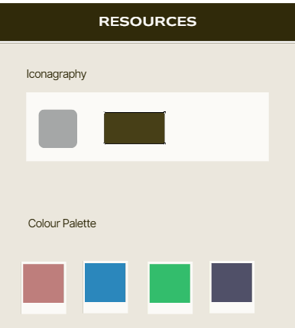

Color Palette:
Soft neutral colors (Ex. Earth Tones,
taupe, and ivory
olive, cream, and tan

Images that match our app’s mood:
